**Analysis Report**

Notes: The orange line represents values from the coinbase dataset and the blue line represents values from the bitstamp dataset.

**January 16th, 2018:**

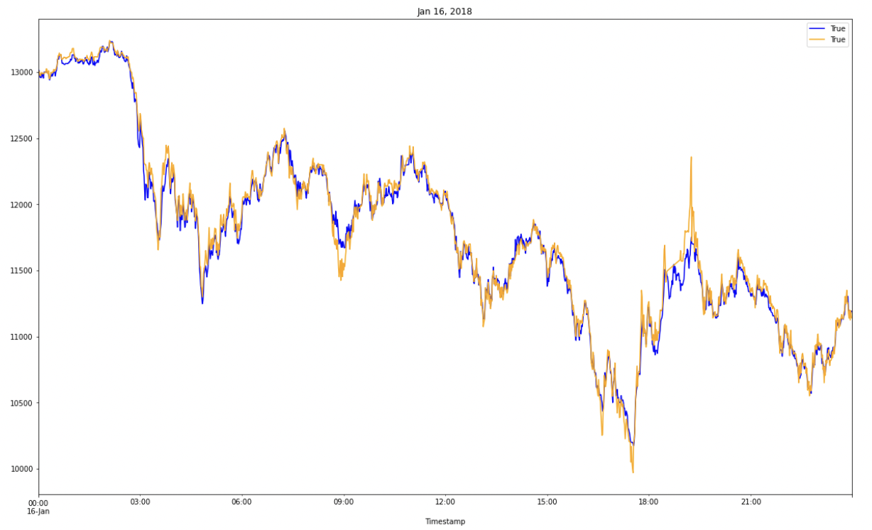

**Figure 1:** Line Plot used to map out arbitrage between bitstamp and coinbase indexes.

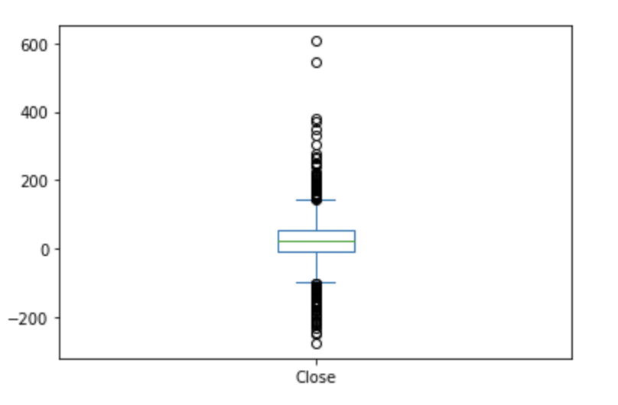

**Figure 2:** Box Plot used to map out arbitrage spread between bitstamp and coinbase indexes.

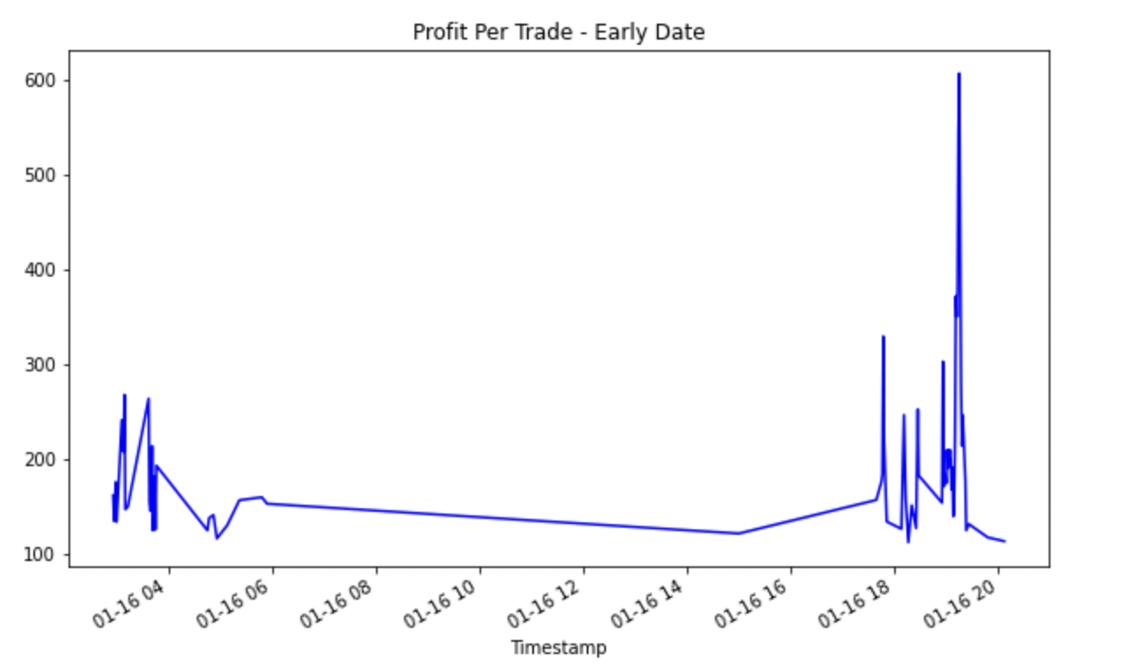

**Figure 3:** This image describes the profits per trade due to arbitrage at a certain point in time.

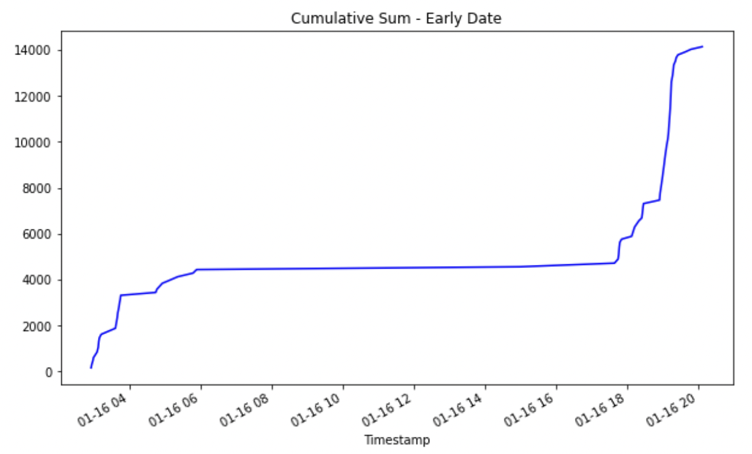

**Figure 4:** This image describes the cumulative profit over a period of time due to arbitrage.

Analysis for January 16th, 2018: Based on the images provided above, we notice that we can get a considerable amount of profit due to arbitrage. The maximum potential profit is $14147.17.

**February 24th, 2018:**

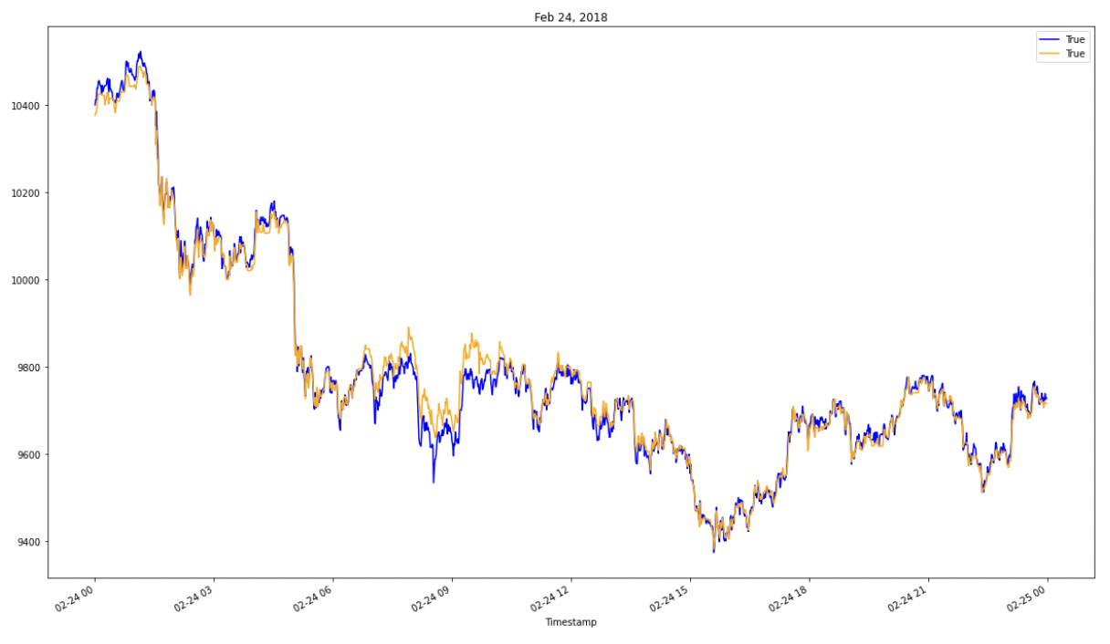

**Figure 5:** Line Plot used to map out arbitrage between bitstamp and coinbase indexes.

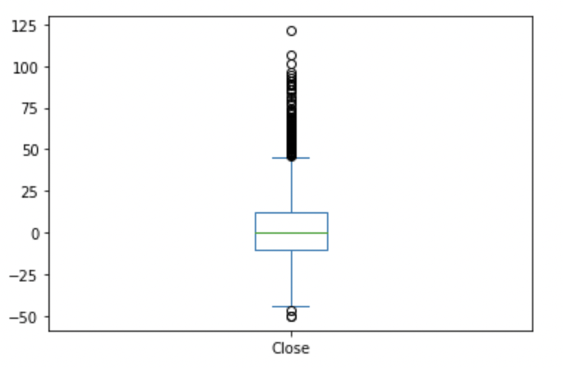

**Figure 6:** Box Plot used to map out arbitrage spread between bitstamp and coinbase indexes.

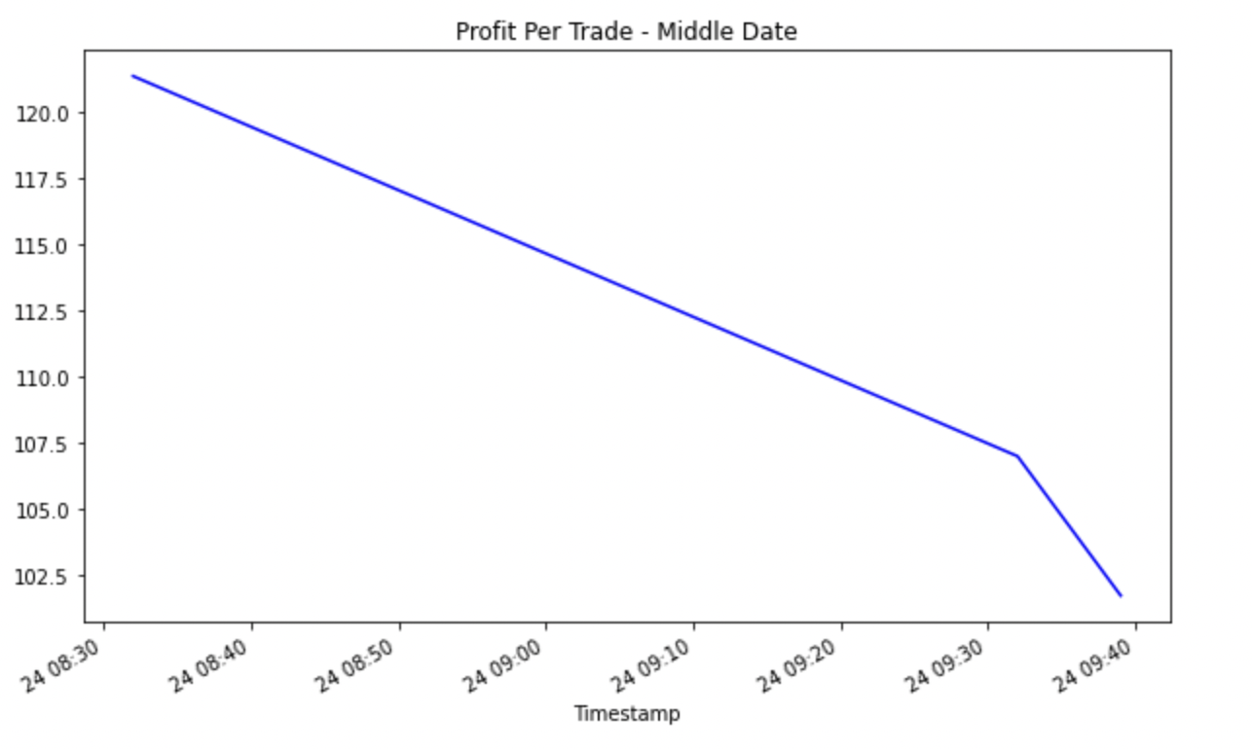

**Figure 7:** This image describes the profits per trade due to arbitrage at a certain point in time.

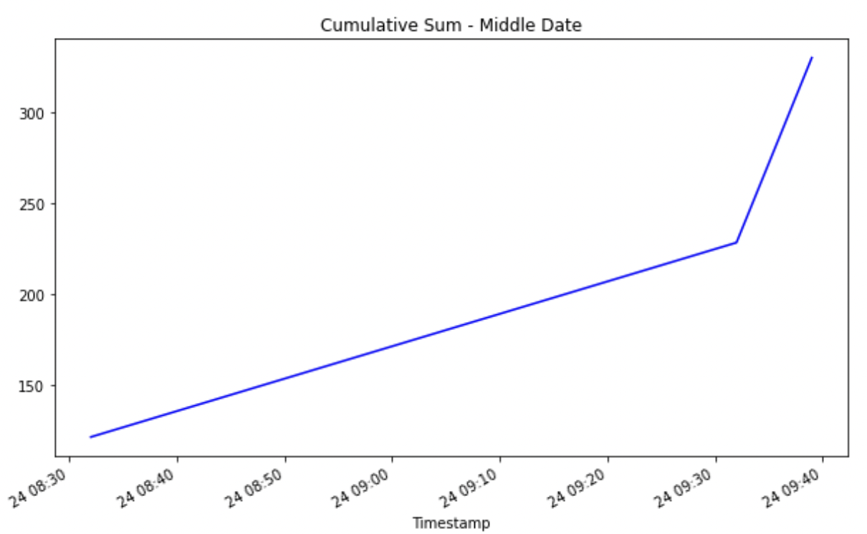

**Figure 8:** This image describes the cumulative profit over a period of time due to arbitrage.

Analysis for February 24th, 2018: Based on the images provided above, we notice that we can still get an amount of profit due to arbitrage. The maximum potential profit is $330.07.

**March 10th, 2018:**

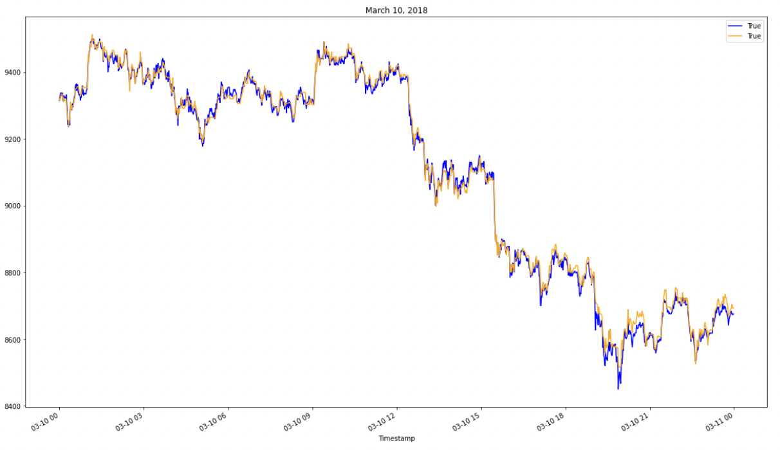

**Figure 9:** Line Plot used to map out arbitrage between bitstamp and coinbase indexes.

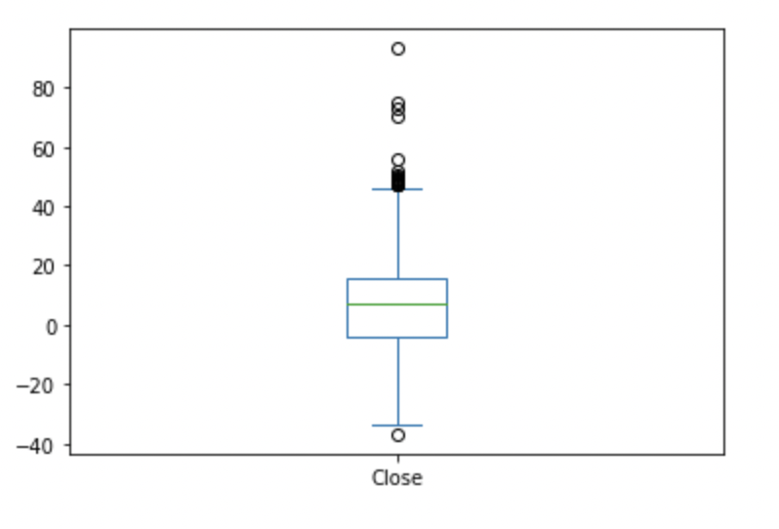

**Figure 10:** Box Plot used to map out arbitrage spread between bitstamp and coinbase indexes.

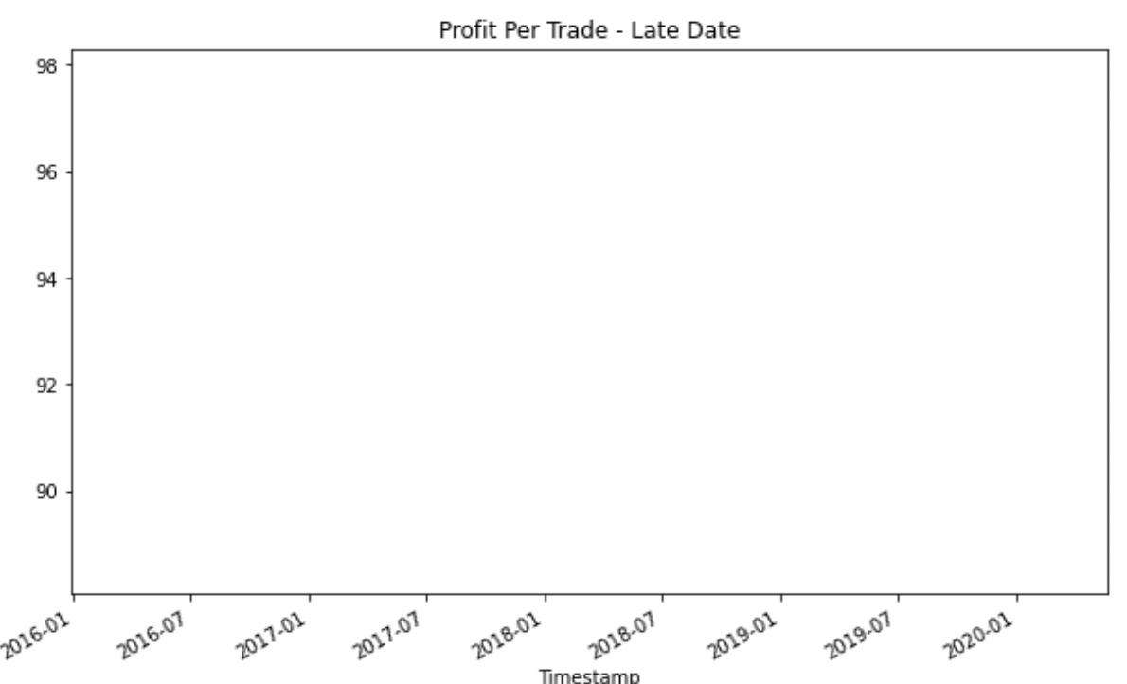

**Figure 11:** This image describes the profits per trade due to arbitrage at a certain point in time.

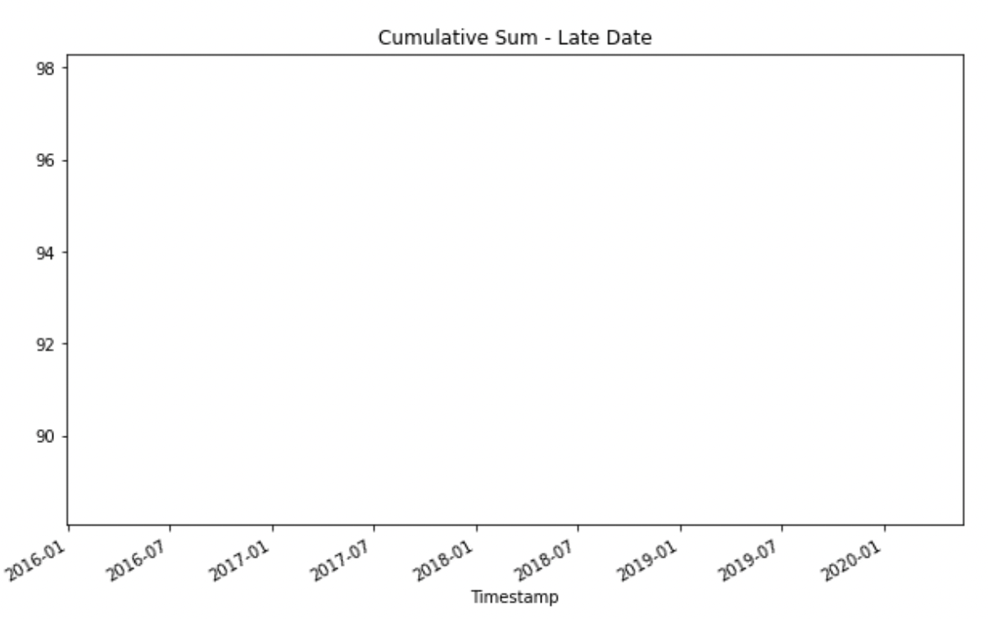

**Figure 12:** This image describes the cumulative profit over a period of time due to arbitrage.

Analysis for March 10th, 2018: Based on the images provided above, we notice that we can still get an amount of profit due to arbitrage. The maximum potential profit is $93.18. The images for cumulative sum and profit per trade is constant so they do not have a visible line.

Calculations:

1. Total profits made from arbitrage over time = 𝚺(Asset Price in Market 1 - Asset Price in Market 2)